**COMET BAY COLLEGE**

**Physics - Unit 1 - Task 1**

**Pretest**

**Name: Solutions Total Marks /64**

**Question 1:**

Find the value of the variable (the letter) in the following;

(a) 5 = t + 13 **[1 mark]**

5 = t + 13

t = -8 (1 mark)

(b) 5a2 = 3a2 + 8 **[2 marks]**

5a2 = 3a2 + 8

2a2 = 8 (1 mark)

a = ± 2 (1 mark)

(c) 0 = $\frac{6y}{8}$ + 12  **[3 marks]**

0 = $\frac{6y}{8}$ + 12

-12 = $\frac{6y}{4}$ (1 mark)

-48 = 6y (1 mark)

y = -8 (1 mark)

(d) -6 = $\frac{4h^{2}}{7}$ + 12 **[3 marks]**

-6 = $\frac{-4h^{2}}{7}$ + 12

-18 = $\frac{-4h^{2}}{7}$ (1 mark)

-126 = -4h2 (1 mark)

31.5 = h2

h = ± 5.61 (1 mark)

(e) 8b = b2 + 16 **[3 marks]**

8b = b2 + 16

0 = b2 - 8b + 16 (1 mark)

0 = (b – 4)(b – 4) (1 mark)

b = + 4 (1 mark)

(f) 10 – 18k = 3k2 - 9k - 20 **[4 marks]**

10 – 18k = 3k2 - 9k - 20

0 = 3k2 + 9k - 30 (1 mark)

0 = 3(k2 + 3k – 10) (1 mark)

0 = 3(k – 2)(k + 5) (1 mark)

k = 2, -5 (1 mark)

**Question 2:**

Solve to:

1. 2 significant figures

(i) 2.4567 = 2.5 (1 mark)

(ii) 0.0068 = 0.01 (1 mark)

(i) 255354 = 2.554 × 104 (1 mark)

(ii) 0.000064548676 = 6.455 × 10-5 (1 mark)

(iii) 1000.678 = 1.001 × 102 (1 mark)

(i) 2.4567 **[1 mark]**

(ii) 0.0068 **[1 mark]**

(b) Scientific notation and four significant figures

(i) 255354 **[1 mark]**

(ii) 0.000064548676 **[1 mark]**

(iii) 100.0678 **[1 mark]**

**Question 3:**

A plane passes over the equator, travelling at a velocity of 1002 km h-1 at an altitude of 12 km. What is the speed in SI units? **[2 marks]**

1002 × $\frac{1000}{3600}$ (1 mark)

= 2.78 × 103 m s-1 (1 mark)

**Question 4:**

A jogger travels a distance of 4500 metres between two trees in a time of 12 minutes. At what speed does it travel? **[2 marks]**

v = $\frac{s}{t}$ = $\frac{4500}{12 × 60}$ (1 mark)

v = 6.25 m s-1 (1 mark)

**Question 5:**

Next to each indicate whether it is a **scalar** or **vector** quantity. **[1 mark each]**

Vector

Scalar

Scalar

Vector

Scalar

1. Momentum (p = m × v) _________________
2. Time _________________
3. Speed _________________
4. Acceleration _________________
5. Temperature _________________

**Question 6:**

**North**

Solve the following vectors (include diagrams):

**D: 7 m s-1**

**B: 5 m s-1**

**C: 3 m s-1**

**A: 5 m s-1**

1. B + D **[1 mark]**

**Resultant: 2 m s-1 west**

**Resultant: 8 m s-1 north**

**Resultant: 5.83 m s-1**

**S 59o E**

**Resultant: 12.2 m s-1**

**N 81o E**

**B: 5 m s-1**

**D: 7 m s-1**

**R: 2 m s-1**

1. A – C **[2 marks]**

**A: 5 m s-1**

**C: 3 m s-1**

**R: 8 m s-1**

1. B + C **[3 marks]**

**R: 5.83 m s-1**

**B: 5 m s-1**

**C: 3 m s-1**

1. A + B + C – D **[3 marks]**

**A: 5 m s-1**

**C: 3 m s-1**

**B: 5 m s-1**

**D: 7 m s-1**

**R: 12.2 m s-1**

**Question 7:**

(a) What is convection in terms of heating and cooling? **[1 mark]**

The liquid or gas is heated and decreases in density, resulting in it rising and allowing cooler more dense material to replace it. (1 mark)

Or similar

(b) What is radiation in terms of heating and cooling? **[1 mark]**

Emission of heat rays from an object that is hot. (1 mark)

Or similar

(c) Railway lines are joined using “fish plates” shown below. Comment on this method of joining (as opposed to welding) and why it is necessary. Explain in terms of heating and cooling of objects.

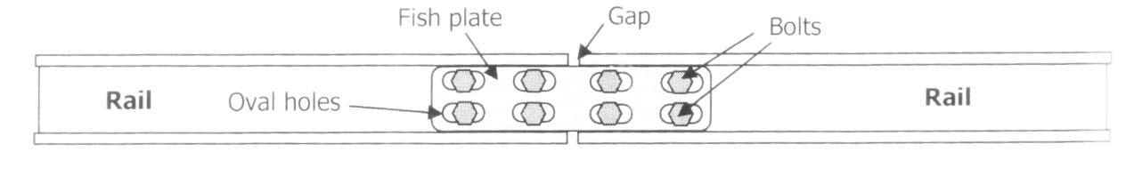 **[2 marks]**

Long lengths of rail line will experience large extension when heated in the Sun. (1 mark)

Gaps and oval holes allow expansion without lateral distortion of the line. (1 mark)

**Question 8:**

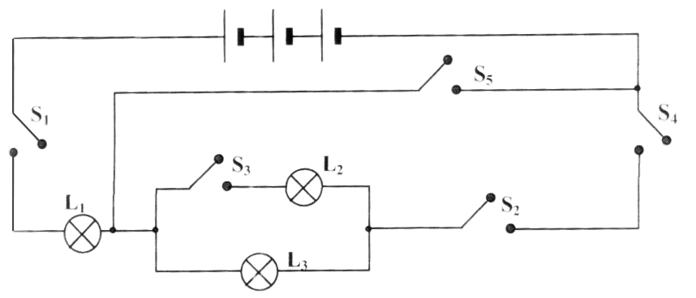Electricity is philosophically considered to be like water. It is lazy and takes the easiest path possible. A series/parallel circuit shown contains 5 switches (S1 to S5) and 3 lamps of equal resistance (L1 to L3).

Which combination of switches that are closed would give the correct sequence of lamps that are on and receiving maximum current? **[1 mark]**

|  |  |  |
| --- | --- | --- |
|  | Switches Closed | Lamps on |
| A | S1, S2, S4 | L1, L2, L3 |
| B | S1, S2, S3, S4, S5 | L1 |
| C | S1, S3, S4, S5 | L1, L2 |
| D | S1, S2, S3, S4 | L1, L3 |

B

Answer: ____________________________________

**Question 9:**

James rides his bicycle along the streets from his home in order to visit Sam. James has to travel 72 m due East, before travelling due South for 41 m. He then travels due East again for another 53 m, then South for 48 m, and finally due West for 18 m. The entire bike ride took 96 seconds.

a) Sketch a diagram showing the journey travelled. **[2 marks]**

1 mark arrows

1 mark direction

72m E

41m S

53m E

48m S

18m W

b) Sketch the resultant horizontal and the resultant vertical components and the overall resultant ? **[2 marks]**

107m E

1 mark arrows

1 mark direction

89m E

c) What is the total displacement from James’s house to Sam’s house? **[4 marks]**

s = $\sqrt{{107}^{2}+ {89}^{2}}$ (1 mark)

= 139.2 m (1 mark)

Φ = tan -1 (1 mark)

= 39.75o

Hence displacement is 139.2 m E 39.75o S (1 mark)

107m E

89m S

Φ

**Question 10:**

The relationship “Current is proportional to applied voltage” is called Ohm’s law, after its discoverer, Georg Ohm. The proportional constant is the slope of the line and represents the resistance of the resistor (R). That is R = $\frac{V}{I}$

An unknown resistor R is placed into a circuit and the circuit current measured for various applied voltages. The results are shown in a table below.

|  |  |  |  |  |  |
| --- | --- | --- | --- | --- | --- |
| Voltage (V) | 1.5 | 3.0 | 4.5 | 6.0 | 7.5 |
| Current (I) | 0.75 | 2.15 | 2.25 | 3.00 | 3.75 |

a) Plot a graph of voltage against current. **[4 marks]**

-1/2 mark for the following not included

correct labelling of axis correct unit of axis

full title (ind v dep) breaks shown clearly and correctly

line of best fit independent variable on x-axis

-1/2 mark for each incorrect point plotted

**Voltage v Current for an Unknown Resistor**

**Question 11:**

Currently, the “Solar System model” of an atom is accepted and used in all facets of Science. Generally, the model consists of a set number of positive protons in the nucleus together with about the same number of neutrons surrounded by electrons which orbit the nucleus in “shells”. The **atomic number** (symbol z) of any atom is the number of protons in the nucleus, which is the same as the number of electrons orbiting for a neutral atom.

The periodic table organises all the elements in our Universe in order of atomic number from 1 (hydrogen) to 92 (uranium). (Other elements with z greater than 92 have now been made in a nuclear reactor).

The **mass number** (symbol A) of an element is the sum of the number of protons plus neutrons in the nucleus, so the **number of neutrons = A – Z**.

An **isotope** is an atom with a particular value of A and Z, for instance sodium-23 is the 11th element in the periodic table and would have the structure: 11p, 12n, 11e in the following shell structure (see diagram):

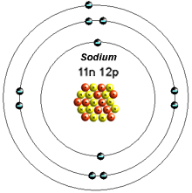

Using atomic symbols sodium-23 is written ${}_{11}^{23}{Na}$. Any element may have several different isotopes, for instance we could also have sodium-22 (${}_{11}^{22}{Na}$) and sodium 24 (${}_{11}^{24}{Na})$, with which each contain a different number of neutrons. All these isotopes have identical chemical properties, but there physical properties are not the same, like melting points, densities, etc.

Hydrogen has three isotopes: Protium ${}_{1}^{1}H$, Deuterium ${}_{1}^{2}H$ and Tritium ${}_{1}^{3}{H. }$ Tritium is radioactive and is called a radioisotope.

a) An element has an atomic structure of: 66 electrons, 96 neutrons and 66 protons. Write the correct symbol for the element showing its atomic number and mass number.

**[2 mark]**

${}_{66}^{162}{Dy}$ 1 mark for Dy,

1 mark for correct location and values of atomic number and mass number

b) The table below shows the structure of elements A to E.

|  |  |  |  |
| --- | --- | --- | --- |
| Element | Proton Number | Neutron Number | Electron Number |
| A | 15 | 15 | 18 |
| B | 17 | 18 | 18 |
| C | 16 | 16 | 16 |
| D | 17 | 17 | 17 |
| E | 15 | 16 | 16 |

i) Which pair(s) of elements in the table are isotopes? **[2 marks]**

A and E are pairs and B and D are pairs

ii) Explain why these are pair(s) of isotopes.  **[2 marks]**

Isotopes have the same number of protons (determines element type), but varying number of neutrons (and hence mass number). (1 mark)

A & E are the same element (same number of protons), but have different mass numbers. This is the same with the pair of elements B & D. (1 mark)

Or similar.

c) A canister of chlorine gas is composed of chlorine-35 atoms and chlorine-37 atoms. If the percentage of these are fixed at 77.5% Cl-35 and 22.5% Cl-37, calculate the weighted average atomic mass for chlorine. **[2 marks]**

Atomic mass = 0.775 × 35 + 0.225 × 37 (1 mark)

= 35.45 amu (1 mark – units not necessary)